HUMMEL presents their hermetic connectors
For use under the toughest conditions
Their area of application is unusual: extreme pressure, immense highs and lows, and difficult weather conditions. Hermetic connectors from HUMMEL AG are used in some of the toughest environments. They reliably protect against moisture, dirt, dust and differences in pressure. They are used in aviation and space travel, in medical technology, by the navy, in mining as well as in energy, environmental and lab technology. Their place of use can include submarines, satellites, oil rigs, nuclear power plants, navigational instruments or medical devices.
Thanks to their many years of experience, the French connector specialist, JAEGER Connecteurs – a subsidiary of HUMMEL AG – is a pioneer in the challenging field of connection solutions. Their range includes hermetic plugs which can be used as device connectors featuring up to 52 contacts, and can also be used as wall ducts. The connectors are available as welded versions and there are also various screw versions. The high-quality materials also mean they can be put to use in high voltage areas.
The connector housing is made from stainless steel with an optional gold-coating. A main feature of these hermetic plug connectors are the contact inserts which satisfy the strict requirements of air, gas and pressure resistance. HUMMEL AG connectors have gold-plated contacts and an insulating body made of sintered glass located between the pin and housing. This ensures high mechanical strength and a reliable seal. The result is a permanent and reliable pressure difference of 50 bar, a helium leak rate less than 10⁻⁹ mbar l/s, and an operating temperature of between -50°C and +125°C.

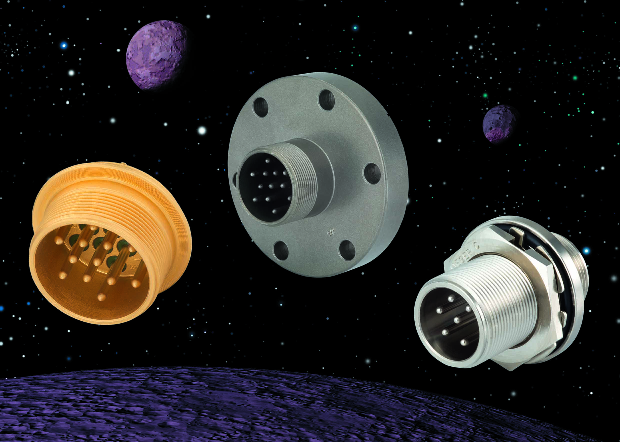

Their areas of applications are always extreme: hermetic connectors are used wherever there are large differences in pressure, big highs and lows, or difficult weather conditions to overcome.
Photo: HUMMEL AG

