HUMMEL AG offers a huge range of M12 panel connectors
M12 Power: Great performance in compact design
This variety is unique in the new M12 power segment: Nine different types of panel connectors, as well as cable, coupling, and right angle connectors, both as field attachable and overmoulded cordsets. Furthermore, each design is available in four different codings K, L, S and T. Hummel’s M12 power range leaves hardly anything to be desired.
Here, designers find solutions for almost any imaginable mounting possibility. Taking a look at the variety of panel connectors is particularly worthwhile. The designer has various options at his disposal: flange, or single-hole mounted type, front- or rear mounting, with female or male threads. An orientable version is also part of the range. The coding of the connectors can thus be oriented in the required direction, even after assembly. This is an essential feature, particularly in situations where right angle connectors are used in a small space.
The performance data of this compact power pack are equally impressive. With a power transmission of 16A, Hummel’s M12 Power (K+L) sets the tone. In combination with its extremely compact design, the M12 connector is a major milestone of miniaturisation. Thanks to the use of new materials, this connector series meets even the highest standards. When connected, the connector meets protection classes IP 67 and IP 69K. The temperature range for K- and L-coded connectors reaches up to 125° Celsius. With their high end rugged metal housing, the M12 connector is particularly suitable to challenging applications in rough environments. Designers thus have a reliable solution even for applications in drive technology at their disposal.

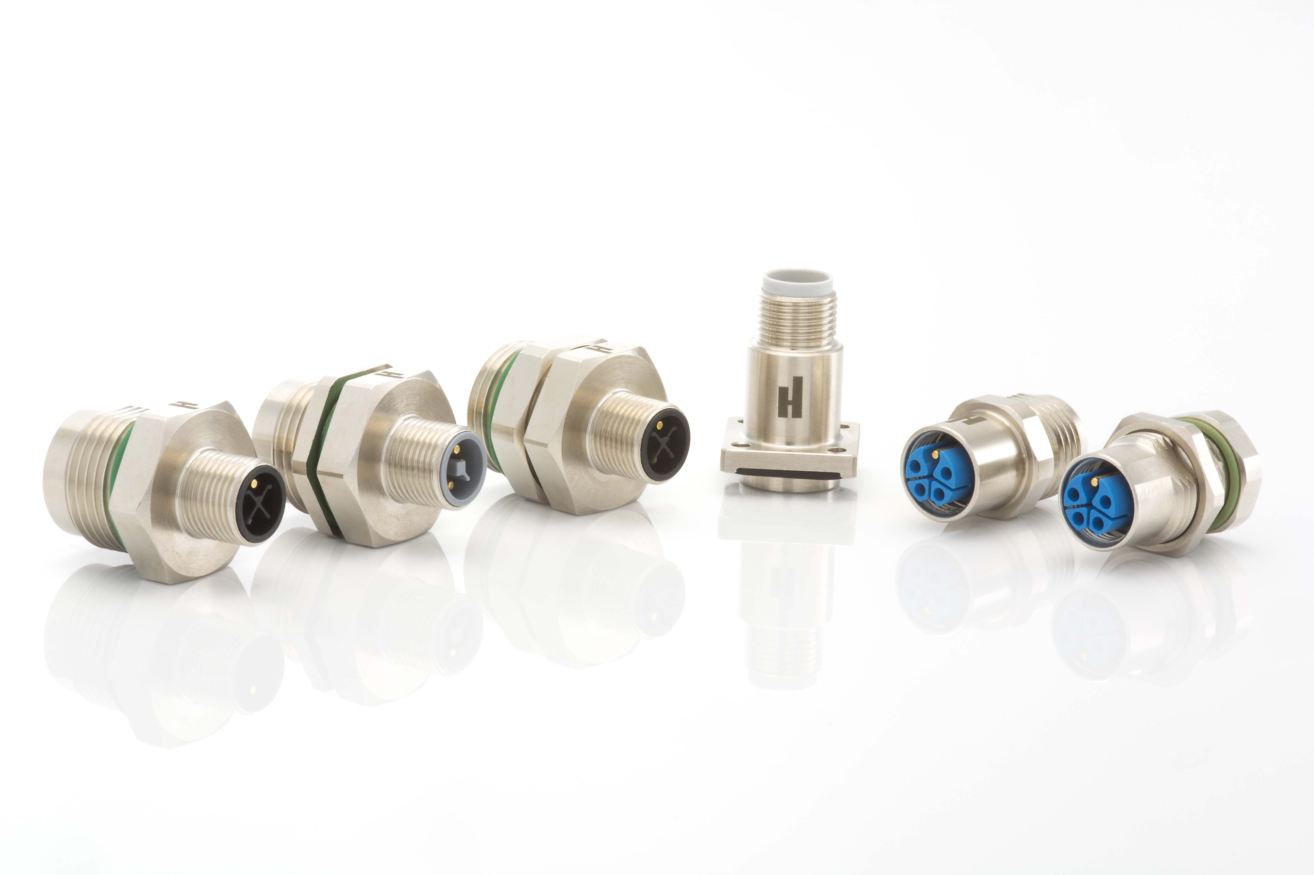
Caption:
The connector series M12 Power is consistently available across all designs in the four codings: T, L, K and S (from left).

